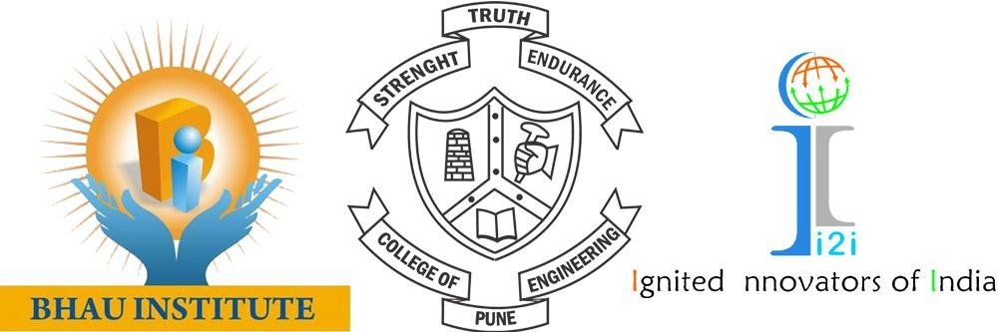

Ignited Innovators of India (i2i)

–Techno-social Competition
Instructions to Participants:
- i2i is a Techno-Social Project Competition which Focuses mainly on the Social Impact, Sustainability and Entrepreneurial Opportunities of the Innovative Projects carried out by the Project Participants.
- It is divided into 5 Phases.

- First Phase (Idea):
- The First Phase starts with the Registration of your Ideas. The Registration portal is Open for One Month.
- New, Innovative and Genuine Ideas are Shortlisted and the Participants get a chance to enter the Second Phase.

- Second Phase (Development/Innovation):
- The Selected Participants get a unique Project Code and are assigned to the Project Ambassadors from COEP.
- These Participants have to develop their Project ideas and make a PowerPoint (.pptx) which gives a brief information on their project and work.
- Good and Implementable Projects are Selected for the Third Phase.

- Third Phase (Implementation):
- The Projects are connected with well-experienced Mentors from EATON who guide the Participants and aid them in their respective Projects.
- The Project Implementation should be Finished by the end of the Third Phase.
- Participants have to submit another PowerPoint with the Details of their Project Implementation along with the required Budget.
- Projects are selected based on their Implementation, Sustainability and Budget required.

- Fourth Phase (Impact):
- A Project Kit and Appropriate Budget is provided to each Selected Project.
- Participants have to work for a good Impact of their Project on the Society. They have to connect with as many People/Organizations as possible.
- The Participants have to send a detailed analysis of the Impact of their Project in the form of PowerPoint.
- The Projects for the Final Phase are selected on the basis of Impact, Sustainability and Efficiency of the Budget used.

- Fifth Phase (Presentation):
- The Participants are invited to COEP to present their Projects in front of the Judging Panel.
- Two Projects from each sector are selected as the Best Projects by the Judging Panel and the Results are announced on the Valedictory Ceremony.

Note:
- The PowerPoint should be submitted within the Due Date with proper discipline.
- The PowerPoint Template will be shared in each Phase to give a brief idea.
- The due dates and result announcement dates will be conveyed in each Phase.
- For more information, contact your College Ambassador.

